Lab 16: Transactions and ACID Properties
Note: pgAdmin shows only the result of the last statement, so each step ends with a SELECT.

Part 1. Setup

Step 1. Create a schema and the tables
DROP SCHEMA IF EXISTS lab16 CASCADE;
CREATE SCHEMA lab16;
SET search_path TO lab16;
CREATE TABLE accounts (
account_id SERIAL PRIMARY KEY,
owner VARCHAR(50),
balance DECIMAL(10,2) CHECK (balance >= 0)
);
CREATE TABLE customers (
customer_id SERIAL PRIMARY KEY,
name VARCHAR(100),
email VARCHAR(100)
);
CREATE TABLE orders (
order_id SERIAL PRIMARY KEY,
customer_id INTEGER REFERENCES customers(customer_id),
total DECIMAL(10,2)
);
CREATE TABLE inventory (
product_id INTEGER PRIMARY KEY,
stock INTEGER
);
CREATE TABLE order_items (
order_id INTEGER REFERENCES orders(order_id),
product_id INTEGER REFERENCES inventory(product_id),
quantity INTEGER
);
CREATE TABLE products (
product_id SERIAL PRIMARY KEY,
name VARCHAR(50),
price DECIMAL(10,2)
);
CREATE TABLE logs (
log_id SERIAL PRIMARY KEY,
message TEXT
);
CREATE TABLE audit_log (
log_id SERIAL PRIMARY KEY,
action VARCHAR(50),
timestamp TIMESTAMP
);
CREATE TABLE users (
id SERIAL PRIMARY KEY,
name VARCHAR(100),
email VARCHAR(100)
);
CREATE TABLE user_preferences (
user_id INTEGER REFERENCES users(id),
theme VARCHAR(20)
);

Step 2. Insert sample data
INSERT INTO accounts (owner, balance) VALUES
('Aibek', 1500.00), ('Ainura', 800.00), ('Bakyt', 3000.00);
INSERT INTO customers (name, email) VALUES
('Aibek Sharshenov', 'aibek@gmail.com');
INSERT INTO inventory (product_id, stock) VALUES
(101, 50), (102, 30);
SELECT * FROM accounts ORDER BY account_id;
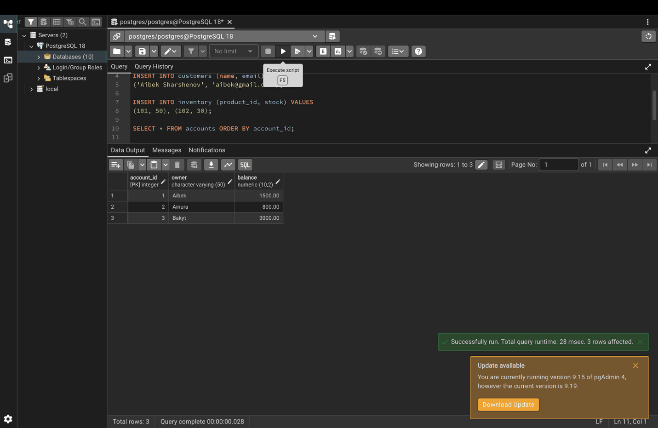

Part 2. BEGIN, COMMIT, ROLLBACK

Step 3. COMMIT: transfer 100 from account 1 to account 2
BEGIN;
UPDATE accounts SET balance = balance - 100 WHERE account_id = 1;
UPDATE accounts SET balance = balance + 100 WHERE account_id = 2;
COMMIT; -- both updates are saved
SELECT * FROM accounts ORDER BY account_id;
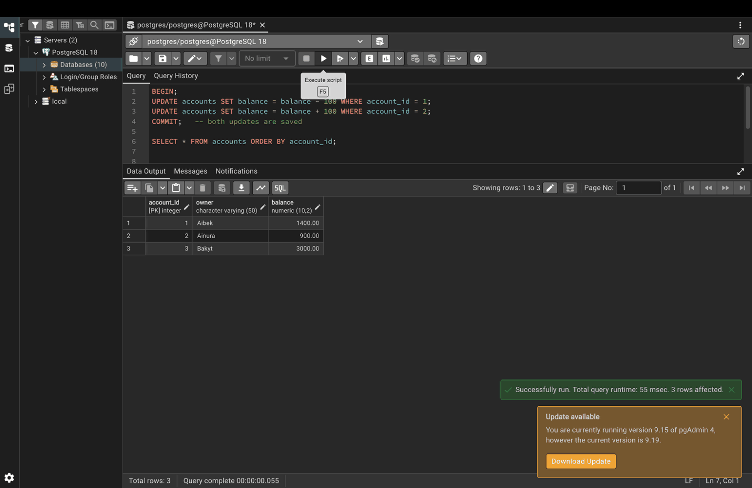

Step 4. ROLLBACK: undo the transfer
The balances are the same as in Step 3.
BEGIN;
UPDATE accounts SET balance = balance - 100 WHERE account_id = 1;
UPDATE accounts SET balance = balance + 100 WHERE account_id = 2;
ROLLBACK; -- both updates are undone
SELECT * FROM accounts ORDER BY account_id;
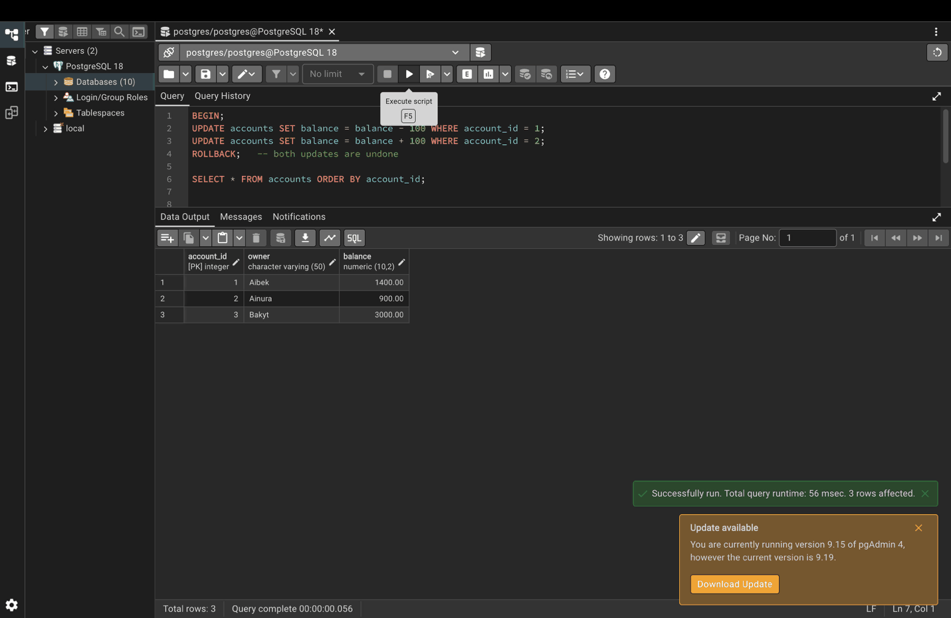

Step 5. Transfer 500 after checking the balance
BEGIN;
SELECT balance FROM accounts WHERE account_id = 1; -- 1400, enough for the transfer
UPDATE accounts SET balance = balance - 500 WHERE account_id = 1;
UPDATE accounts SET balance = balance + 500 WHERE account_id = 2;
COMMIT;
SELECT * FROM accounts ORDER BY account_id;
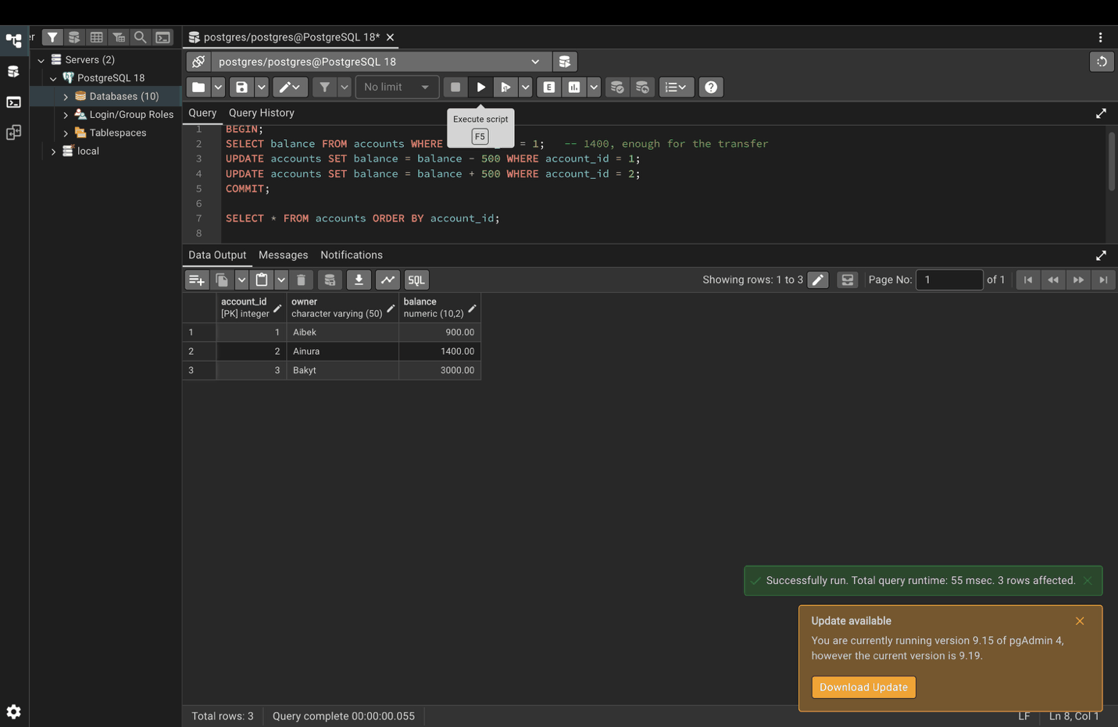

Part 3. ACID properties

Step 6. Atomicity: all operations succeed together
BEGIN;
INSERT INTO orders (customer_id, total) VALUES (1, 250.00);
INSERT INTO order_items (order_id, product_id, quantity) VALUES (1, 101, 2);
UPDATE inventory SET stock = stock - 2 WHERE product_id = 101;
COMMIT;
SELECT * FROM inventory ORDER BY product_id;
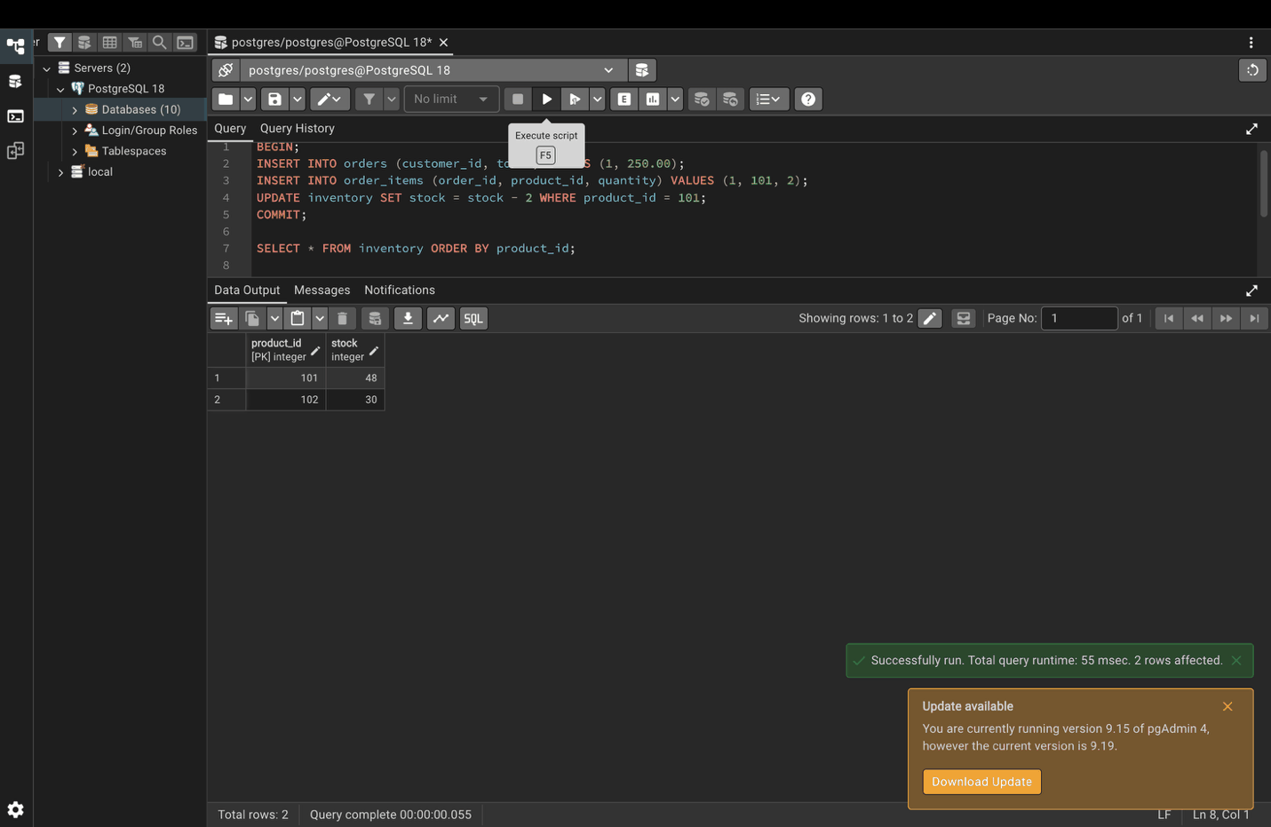

Step 7. Atomicity: one failure undoes everything
The second UPDATE breaks the CHECK constraint, so PostgreSQL shows an error.
BEGIN;
UPDATE accounts SET balance = balance + 5000 WHERE account_id = 2;
UPDATE accounts SET balance = balance - 5000 WHERE account_id = 1; -- fails: balance cannot go below 0
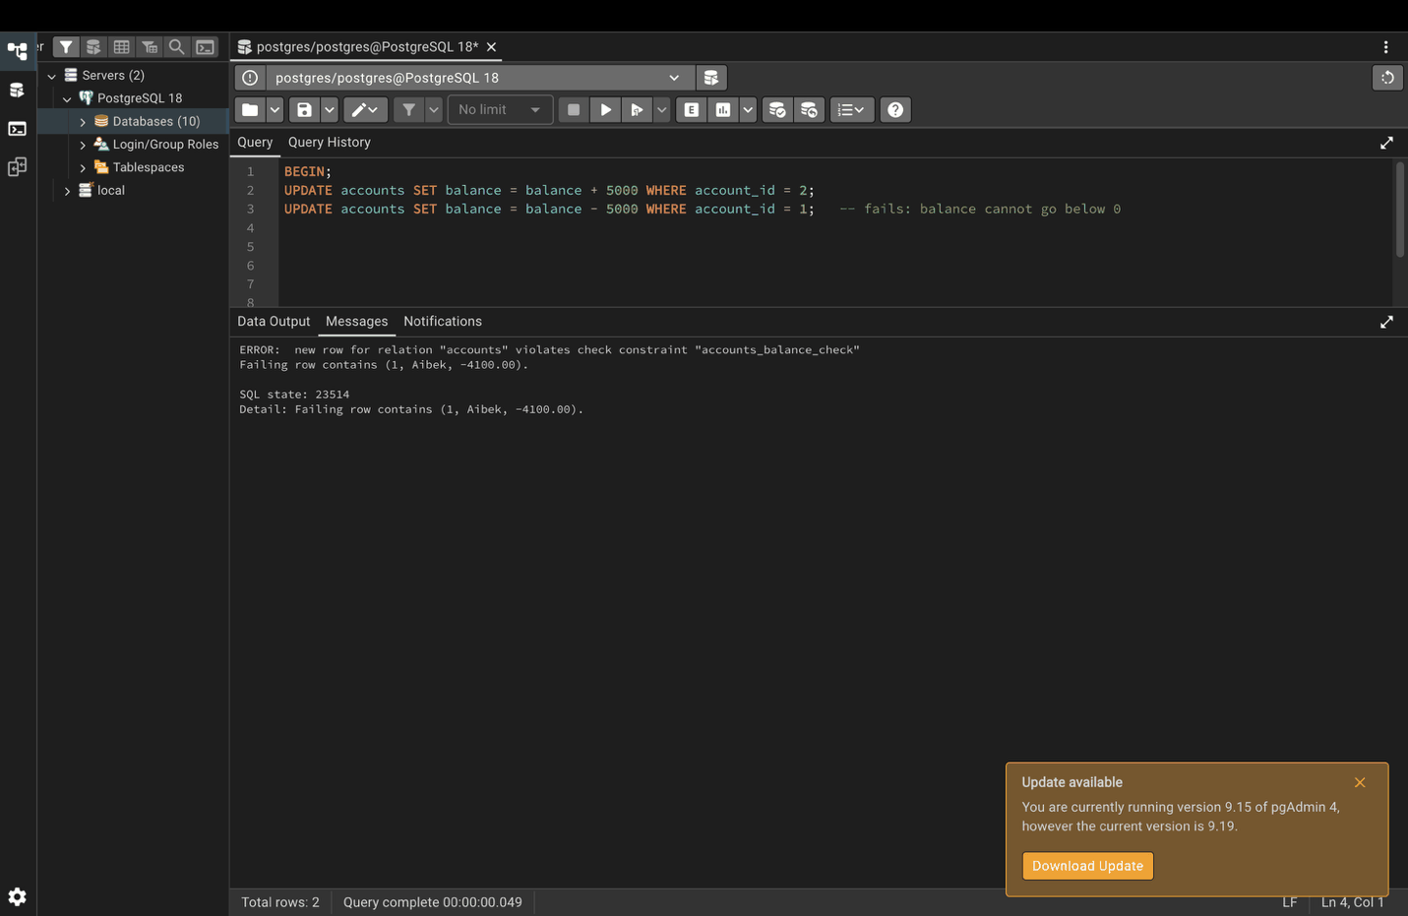Then run ROLLBACK. Account 2 did not get the 5000, because the whole transaction was cancelled.
ROLLBACK;
SELECT * FROM accounts ORDER BY account_id;
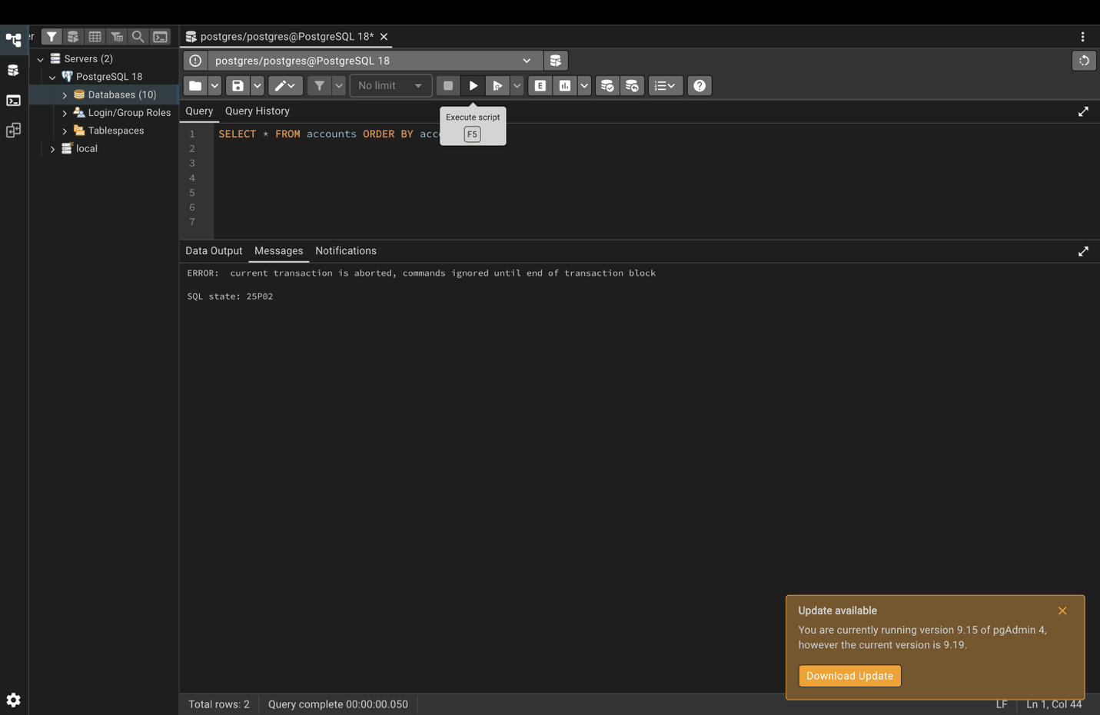

Step 8. Consistency: respecting the foreign key
LASTVAL() returns the id of the customer just inserted, so the order always points to a real customer.
BEGIN;
INSERT INTO customers (name, email) VALUES ('John Doe', 'john@email.com');
INSERT INTO orders (customer_id, total) VALUES (LASTVAL(), 100.00);
COMMIT;
SELECT c.name, o.order_id, o.total
FROM customers c
JOIN orders o ON c.customer_id = o.customer_id;
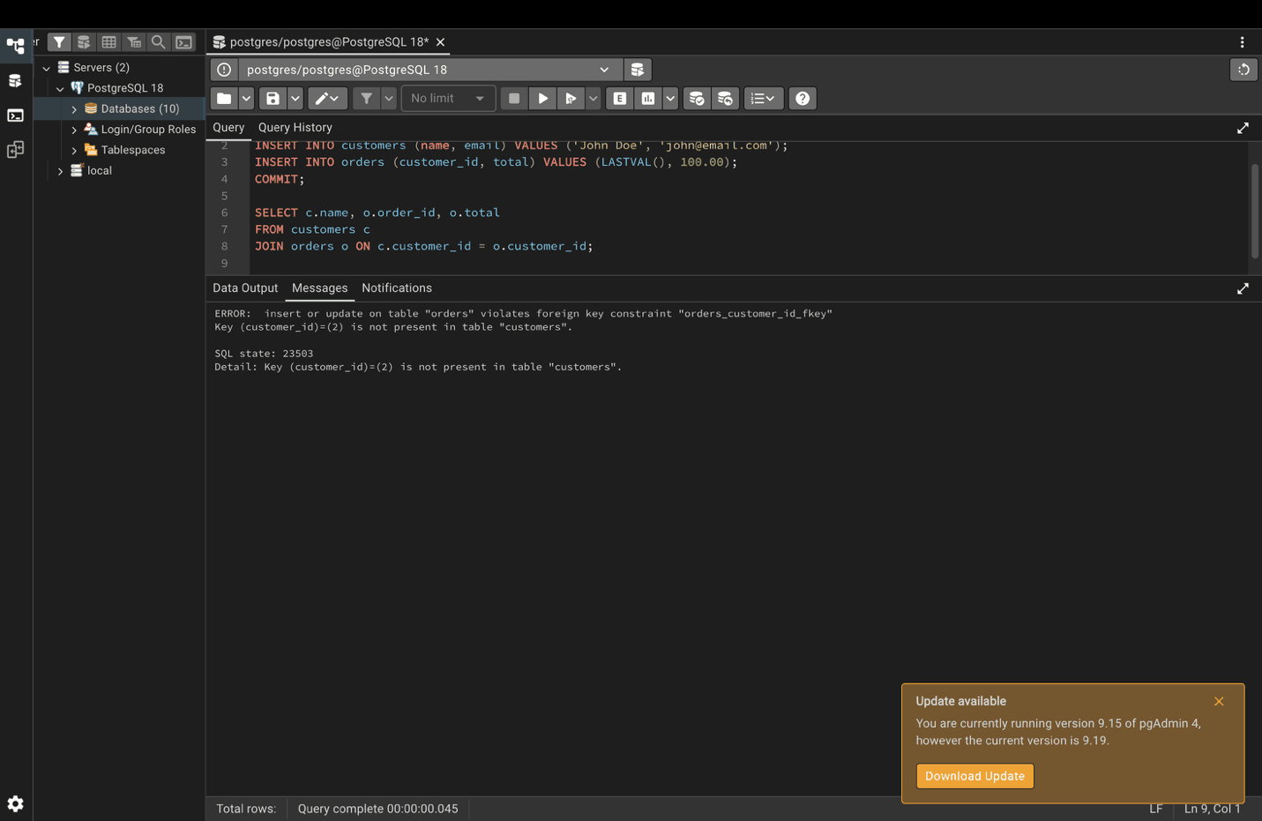

Step 9. Durability: committed data survives a restart
Close pgAdmin completely, open it again, and run this query. The changes committed in Steps 3 and 5 are still there.
SELECT * FROM lab16.accounts ORDER BY account_id;
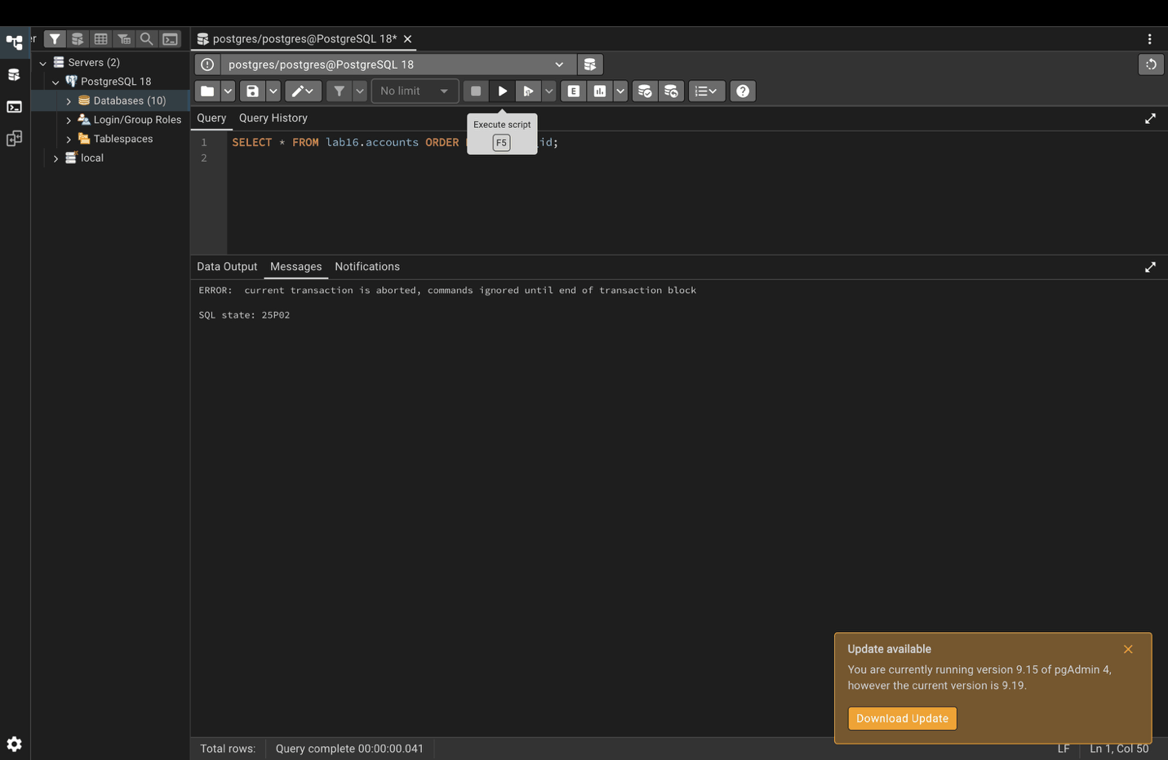

Part 4. Isolation levels
Isolation means transactions running at the same time do not interfere with each other. In each step below, run the first block, take the screenshot, then run COMMIT.

Step 10. READ UNCOMMITTED
PostgreSQL accepts this level but treats it like READ COMMITTED, so dirty reads never happen.
BEGIN TRANSACTION ISOLATION LEVEL READ UNCOMMITTED;
SELECT current_setting('transaction_isolation') AS isolation_level, *
FROM accounts;
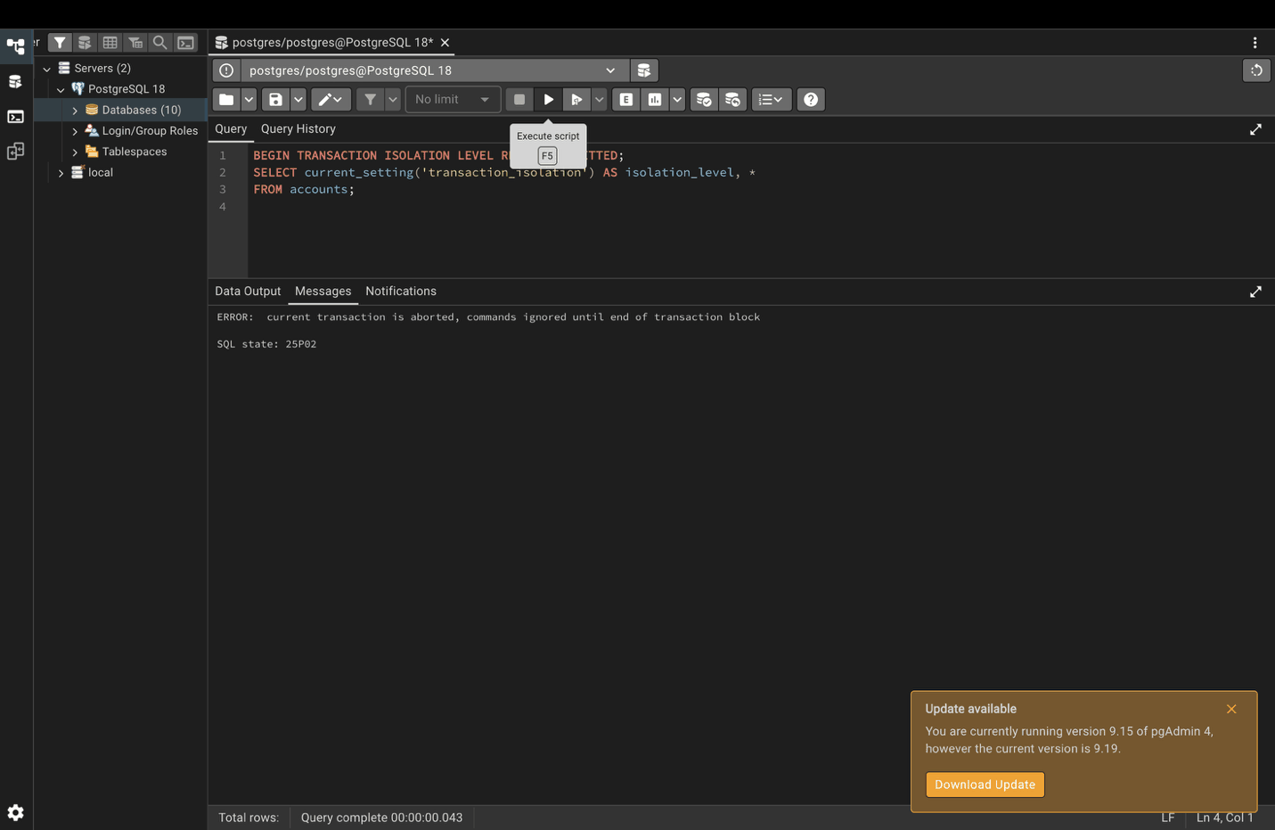COMMIT;

Step 11. READ COMMITTED (default)
BEGIN TRANSACTION ISOLATION LEVEL READ COMMITTED;
SELECT current_setting('transaction_isolation') AS isolation_level, *
FROM accounts WHERE balance > 1000;
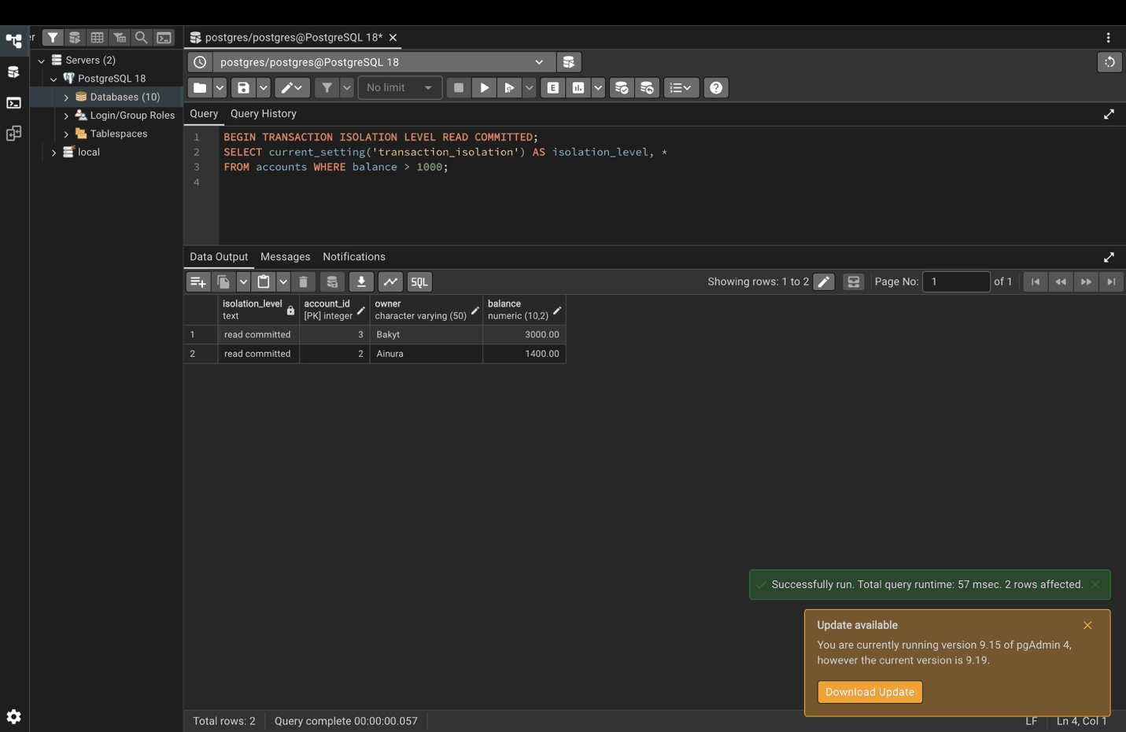COMMIT;

Step 12. REPEATABLE READ
BEGIN TRANSACTION ISOLATION LEVEL REPEATABLE READ;
SELECT current_setting('transaction_isolation') AS isolation_level, *
FROM accounts WHERE balance > 1000;
COMMIT;

Step 13. SERIALIZABLE: add 5% interest
BEGIN TRANSACTION ISOLATION LEVEL SERIALIZABLE;
UPDATE accounts SET balance = balance * 1.05;
SELECT current_setting('transaction_isolation') AS isolation_level, *
FROM accounts ORDER BY account_id;
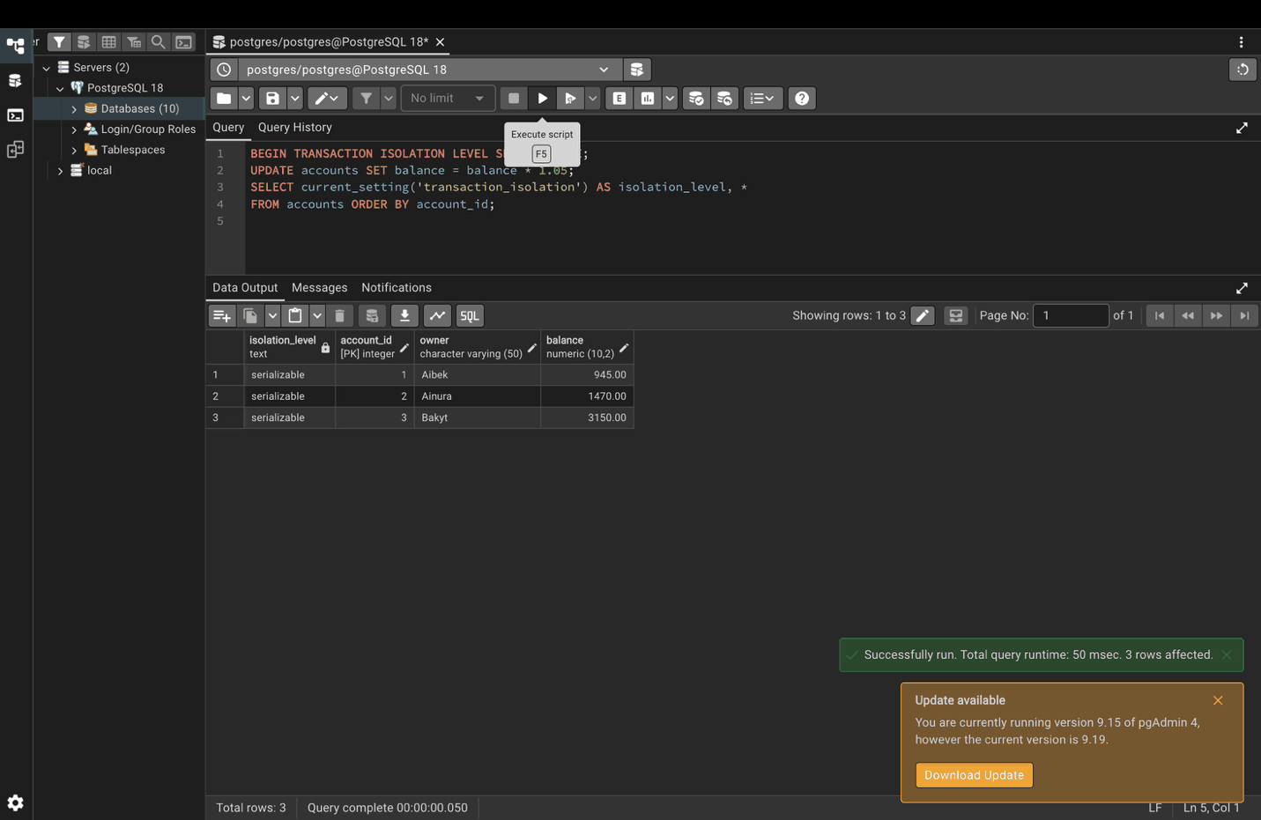COMMIT;

Step 14. SET TRANSACTION
SET TRANSACTION must be the first command after BEGIN.
BEGIN;
SET TRANSACTION ISOLATION LEVEL REPEATABLE READ;
SELECT current_setting('transaction_isolation') AS isolation_level;
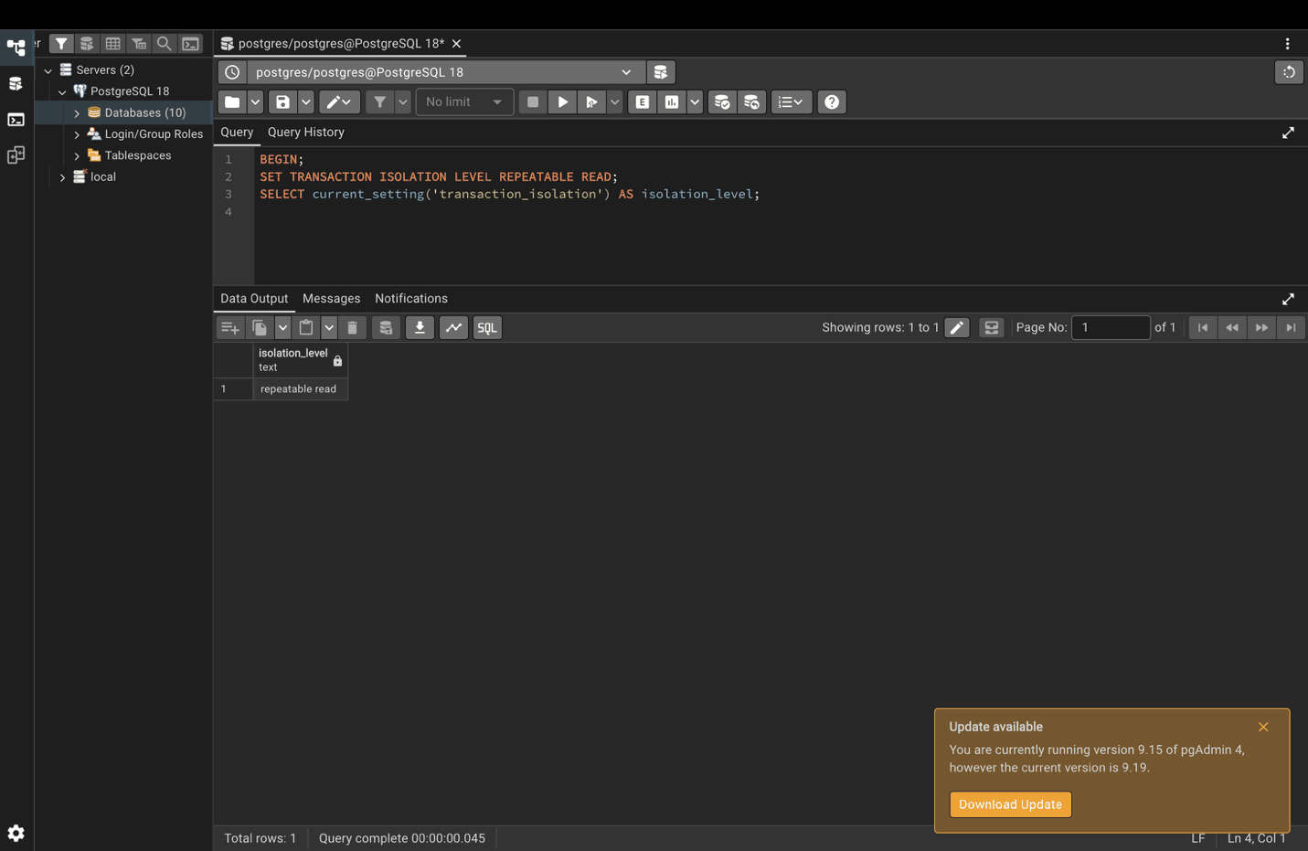COMMIT;

Part 5. Savepoints

Step 15. ROLLBACK TO SAVEPOINT
The 500.00 order is not in the table, but the 300.00 order is.
BEGIN;
INSERT INTO customers (name, email) VALUES ('Alice', 'alice@email.com');
SAVEPOINT after_customer_insert;
INSERT INTO orders (customer_id, total) VALUES (1, 500.00);
ROLLBACK TO SAVEPOINT after_customer_insert; -- the 500 order is undone, Alice stays
INSERT INTO orders (customer_id, total) VALUES (1, 300.00);
COMMIT;
SELECT * FROM orders ORDER BY order_id;
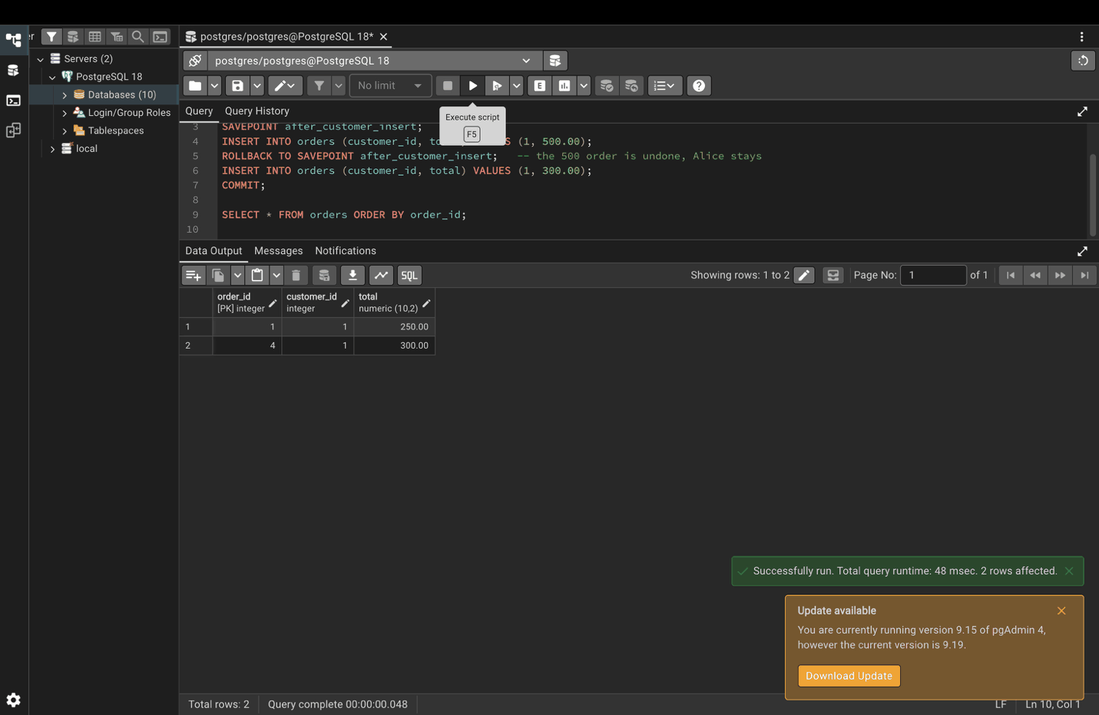

Step 16. Multiple savepoints
BEGIN;
INSERT INTO products (name, price) VALUES ('Laptop', 999.99);
SAVEPOINT sp1;
INSERT INTO products (name, price) VALUES ('Mouse', 25.99);
SAVEPOINT sp2;
INSERT INTO products (name, price) VALUES ('Invalid Product', -50.00);
ROLLBACK TO SAVEPOINT sp2; -- removes only the invalid product
INSERT INTO products (name, price) VALUES ('Keyboard', 79.99);
COMMIT;
SELECT * FROM products ORDER BY product_id;
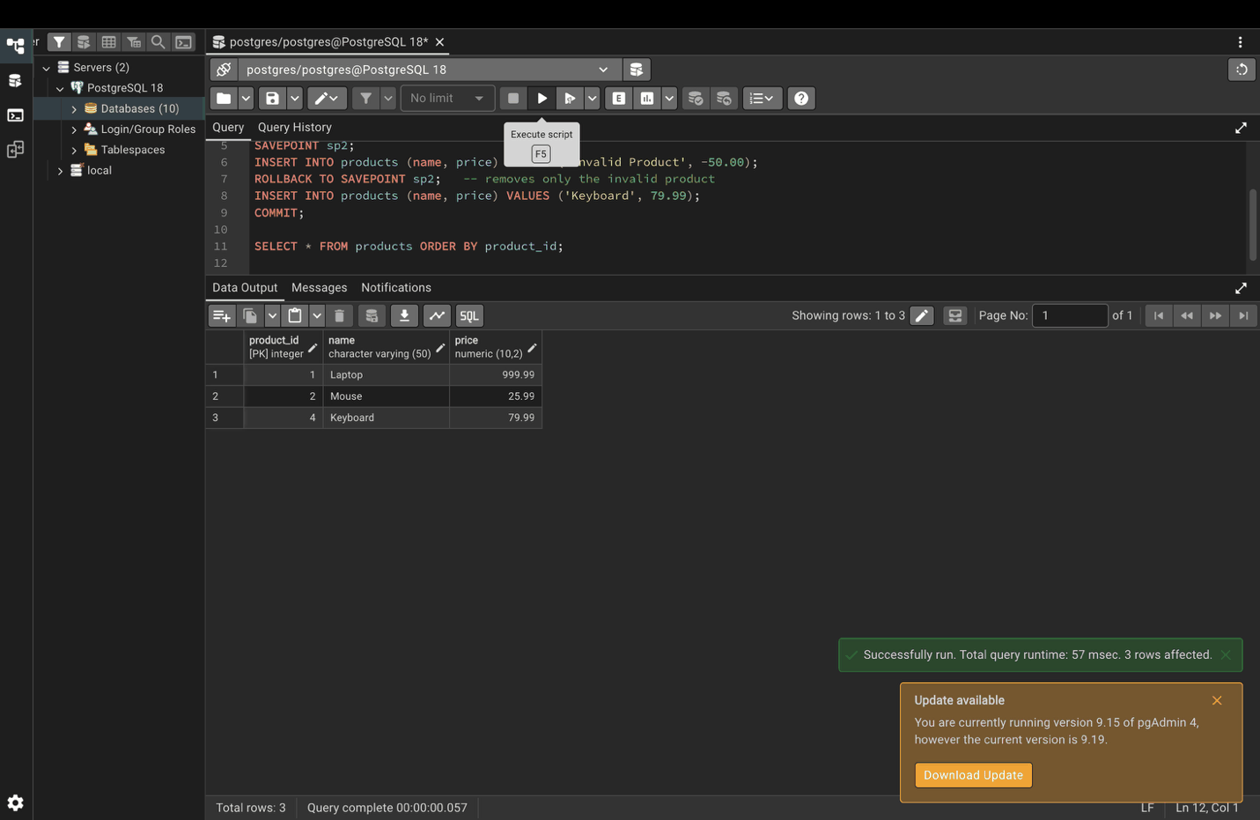

Step 17. RELEASE SAVEPOINT
BEGIN;
INSERT INTO logs (message) VALUES ('Starting process');
SAVEPOINT process_start;
INSERT INTO logs (message) VALUES ('Process completed');
RELEASE SAVEPOINT process_start;
COMMIT;
SELECT * FROM logs ORDER BY log_id;
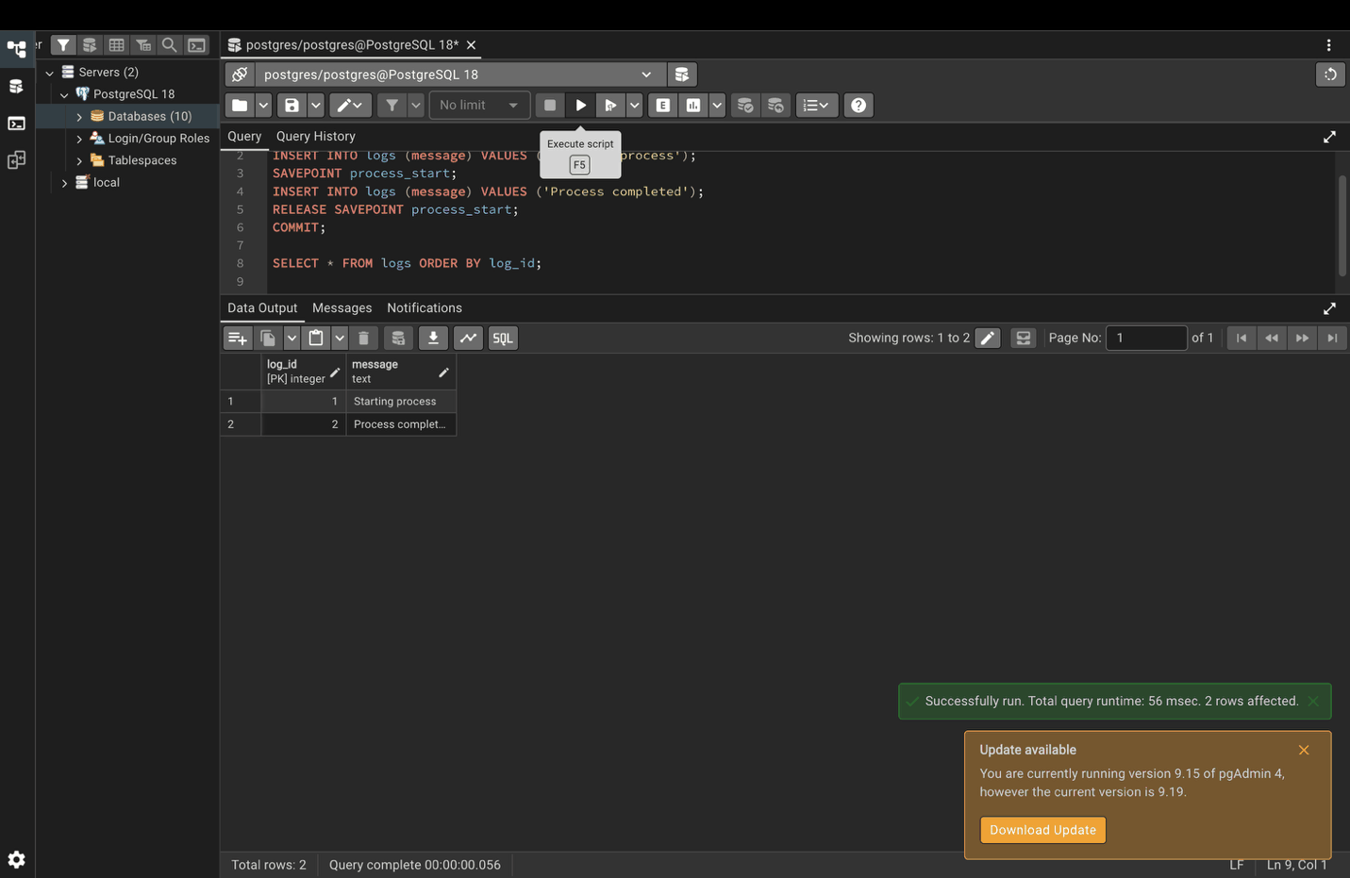

Part 6. Best practices

Step 18. Keep transactions short and focused
BEGIN;
UPDATE inventory SET stock = stock - 1 WHERE product_id = 101;
INSERT INTO order_items (order_id, product_id, quantity) VALUES (1, 101, 1);
COMMIT;
SELECT * FROM inventory ORDER BY product_id;
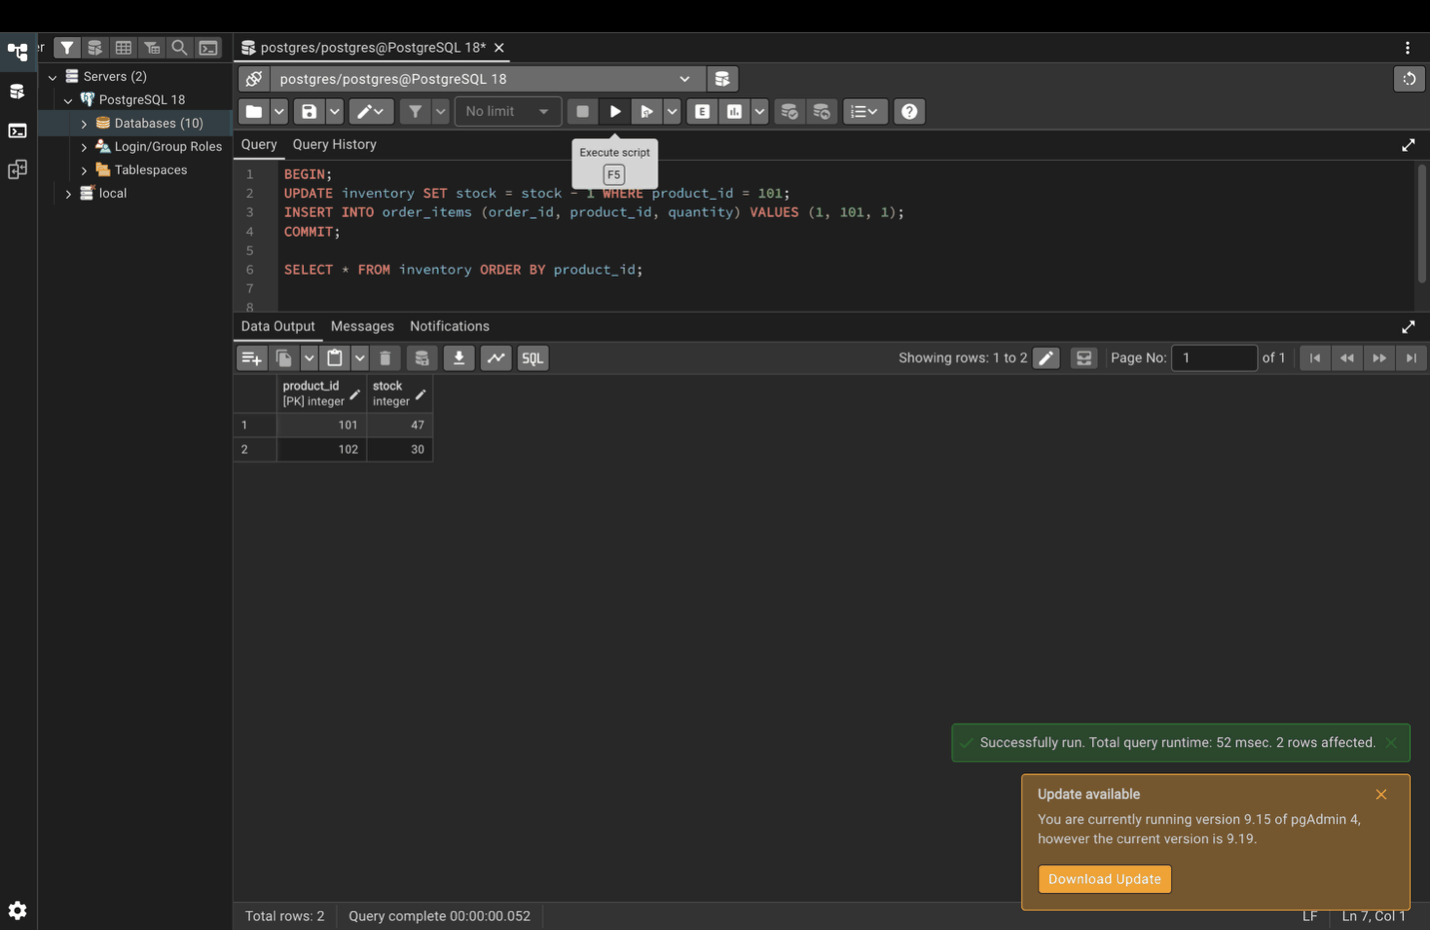

Step 19. Handle errors: insufficient funds
Account 1 has less than 2000, so the transfer is cancelled.
DO $$
DECLARE
current_balance DECIMAL;
BEGIN
SELECT balance INTO current_balance FROM accounts WHERE account_id = 1;
IF current_balance < 2000 THEN
RAISE EXCEPTION 'Insufficient funds';
END IF;
UPDATE accounts SET balance = balance - 2000 WHERE account_id = 1;
UPDATE accounts SET balance = balance + 2000 WHERE account_id = 2;
EXCEPTION
WHEN raise_exception THEN
RAISE NOTICE 'Transaction failed: %', SQLERRM;
END $$;
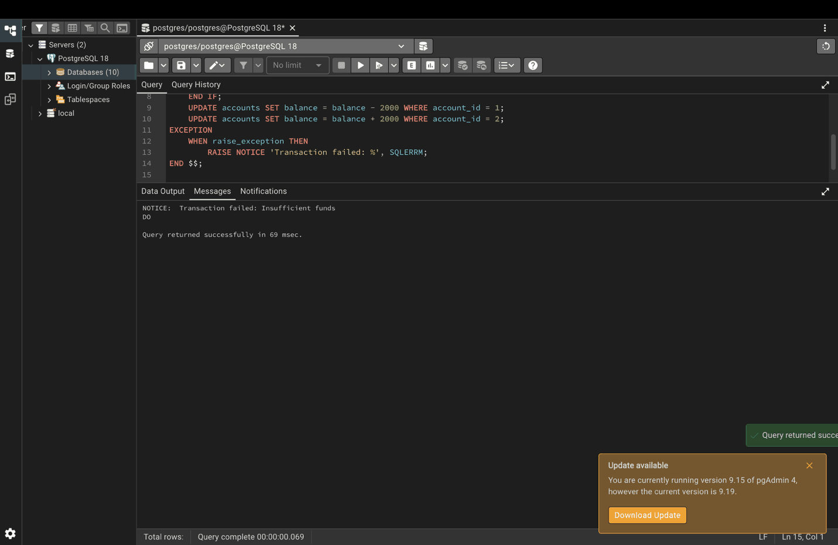

Step 20. Use savepoints for complex operations
BEGIN;
INSERT INTO orders (customer_id, total) VALUES (1, 1000.00);
SAVEPOINT before_items;
INSERT INTO order_items (order_id, product_id, quantity)
VALUES (currval('orders_order_id_seq'), 101, 2);
INSERT INTO order_items (order_id, product_id, quantity)
VALUES (currval('orders_order_id_seq'), 102, 1);
COMMIT;
SELECT * FROM order_items;
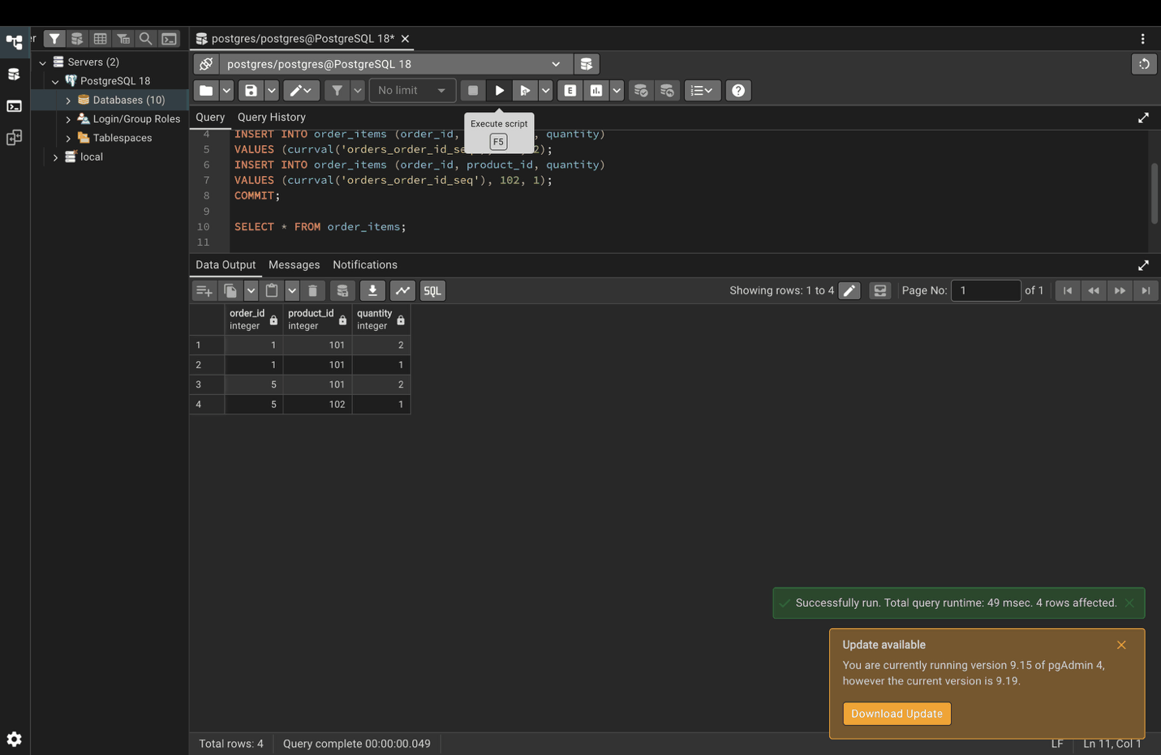

Step 21. Monitor locks and blocked transactions
No transactions are blocked right now, so the result is empty.
SELECT
blocked_locks.pid AS blocked_pid,
blocked_activity.usename AS blocked_user,
blocking_locks.pid AS blocking_pid,
blocking_activity.usename AS blocking_user,
blocked_activity.query AS blocked_statement
FROM pg_catalog.pg_locks blocked_locks
JOIN pg_catalog.pg_stat_activity blocked_activity
ON blocked_activity.pid = blocked_locks.pid
JOIN pg_catalog.pg_locks blocking_locks
ON blocking_locks.locktype = blocked_locks.locktype
JOIN pg_catalog.pg_stat_activity blocking_activity
ON blocking_activity.pid = blocking_locks.pid
WHERE NOT blocked_locks.granted;
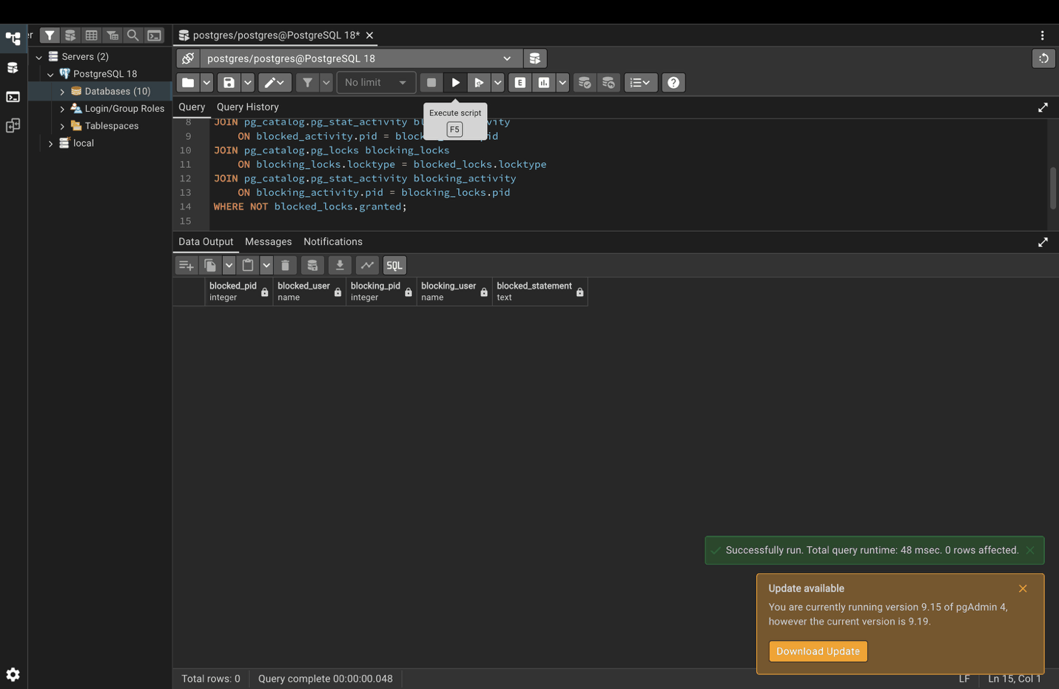

Step 22. Use explicit transactions for related operations
BEGIN;
INSERT INTO audit_log (action, timestamp) VALUES ('user_creation', NOW());
INSERT INTO users (name, email) VALUES ('John Doe', 'john@example.com');
INSERT INTO user_preferences (user_id, theme) VALUES (currval('users_id_seq'), 'dark');
COMMIT;
SELECT u.name, u.email, up.theme
FROM users u
JOIN user_preferences up ON u.id = up.user_id;


